Jordan Isaac
CS499
CS 499

Milestone Three Enhancement Two: Algorithms and Data Structures
Artifact: CS465 Travlr Getaways
Brief Description of the Artifact
The artifact I selected for the algorithms and data structures enhancement is my CS465 Travlr Getaways full-stack web application. This project was originally developed during the Full Stack Development course and functions as a travel booking and trip management system. The application allows public users to browse travel destinations while authenticated administrators can create, update, and delete trip information through a secured Angular administrative interface. The application was developed using Angular, Node.js, Express, MongoDB, and Mongoose. Communication between the frontend and backend occurs through a RESTful API architecture, while MongoDB stores trip information using document-based collections. The application utilizes JavaScript objects, arrays, JSON responses, and MongoDB documents to manage trip data throughout the system while asynchronous processing supports communication between the frontend, backend, and database layers. I selected this artifact because it provides a strong example of how algorithms and data structures are implemented within a modern full-stack application.

Justification for Inclusion in the ePortfolio
I selected this artifact for inclusion in my ePortfolio because it demonstrates my ability to analyze existing software systems and improve performance through algorithmic enhancements and data structure optimization. During the code review process, I evaluated how trip records were retrieved, processed, and displayed throughout the application. The review identified several opportunities to improve scalability and efficiency. The original implementation retrieved all trip records from the database whenever trip information was requested. While this approach worked for small datasets, it would become increasingly inefficient as the application expanded and additional trip records were added.
To address this limitation, I implemented pagination functionality within the backend API. Pagination retrieves smaller subsets of records by utilizing page numbers, record limits, and skip calculations rather than returning the entire collection. This enhancement significantly reduces unnecessary database retrieval and improves scalability. I also implemented search functionality using MongoDB regular expression queries, allowing users to retrieve specific trip records based on trip names instead of processing the full collection. In addition, I implemented sorting functionality that enables trip records to be organized according to selected fields. Together, these enhancements improve performance, reduce database workload, and create a more efficient user experience while demonstrating practical applications of algorithms and data structures within a full-stack environment.

Course Outcomes
This enhancement supports several Computer Science program outcomes. First, it demonstrates my ability to design, develop, and evaluate computing solutions using algorithmic thinking and modern software development practices. The implementation of pagination, search, and sorting functionality required analyzing system performance and selecting appropriate techniques to improve efficiency. Second, the enhancement demonstrates my ability to apply well-founded computing practices to improve scalability and maintainability. Pagination reduces unnecessary processing by limiting database retrieval, while search and sorting algorithms provide more efficient access to data collections. Finally, the enhancement demonstrates my ability to evaluate existing software systems, identify areas for improvement, and implement optimized solutions that enhance performance and usability. Compared to my original planning, the enhancement evolved beyond simple database optimization and became a larger improvement involving scalable data retrieval techniques, query optimization, and improved collection management.

Reflection on the Enhancement Process
The enhancement process strengthened my understanding of algorithms, data structures, and database performance optimization within full-stack applications. One of the most valuable lessons involved understanding how inefficient data retrieval can impact scalability as applications grow. Implementing pagination demonstrated how relatively simple algorithmic improvements can significantly reduce system workload and improve performance. I also gained experience implementing search functionality using MongoDB regular expressions and learned how optimized database queries can improve both efficiency and user experience. Another important lesson involved coordinating enhancements across multiple application layers, including the Angular frontend, Express backend, and MongoDB database. Ensuring that pagination, searching, and sorting functionality operated consistently across the entire application required extensive testing and debugging. Overall, this enhancement strengthened my understanding of data retrieval algorithms, database query optimization, asynchronous processing, RESTful API development, and scalable software architecture while demonstrating substantial progress toward several Computer Science program outcomes.

Figure 1. Original Trip Collection Display
This screenshot shows the Trip List component displaying trip records retrieved from the MongoDB database. The Angular frontend dynamically renders trip information received through the REST API. This represents the baseline functionality before search and pagination are applied.



Figure 2. Search Algorithm Enhancement Filtering Trip Records
This screenshot demonstrates the search enhancement implemented during the algorithms and data structures modification process. The search functionality utilizes MongoDB regular expression matching to retrieve only records that contain the specified search term. This enhancement improves efficiency by reducing unnecessary data processing and allows users to quickly locate specific trip records.


Figure 3. Pagination Algorithm – First Page Results
This screenshot demonstrates the pagination enhancement displaying the first page of trip results. Instead of retrieving the entire database collection, the application retrieves only a subset of records based on the selected page number and page size. This improves scalability and reduces database workload.

Figure 4. Pagination Algorithm – Second Page Results
This screenshot demonstrates the second page of paginated results. The application uses skip and limit calculations to retrieve a different subset of records from the database. This enhancement demonstrates practical implementation of collection management and efficient data retrieval algorithms.
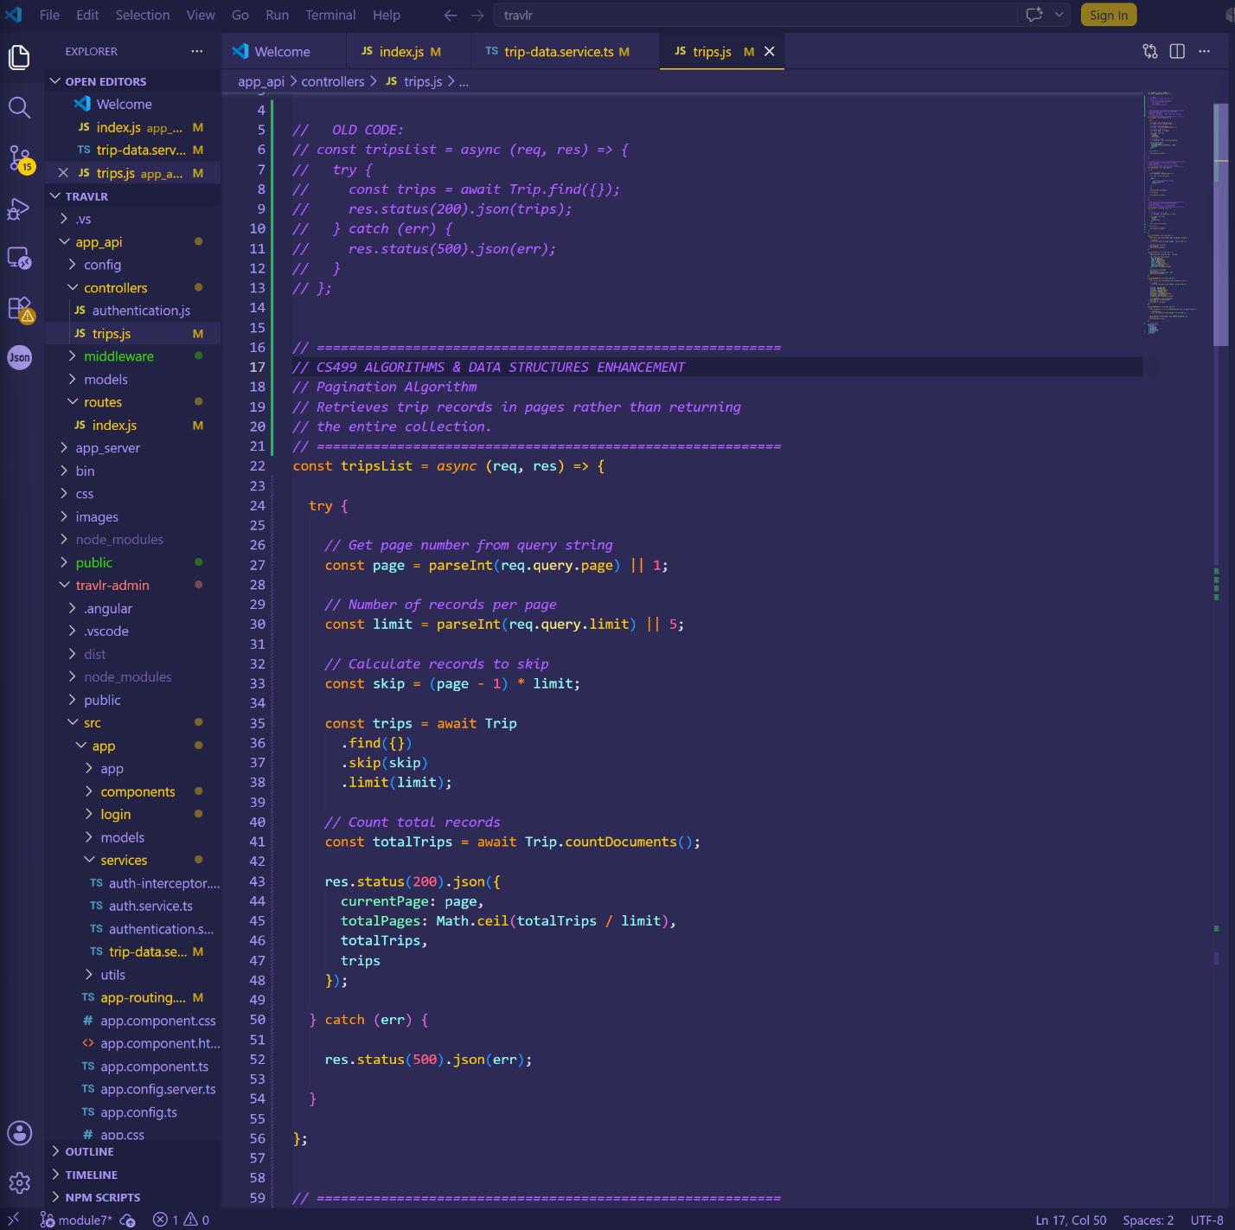
Figure 5. Backend Pagination Algorithm Implementation
This screenshot displays the backend pagination implementation within the Express controller. The algorithm calculates page size, record limits, and skipped records before querying MongoDB. This enhancement reduces unnecessary retrieval of large collections and improves overall application performance.
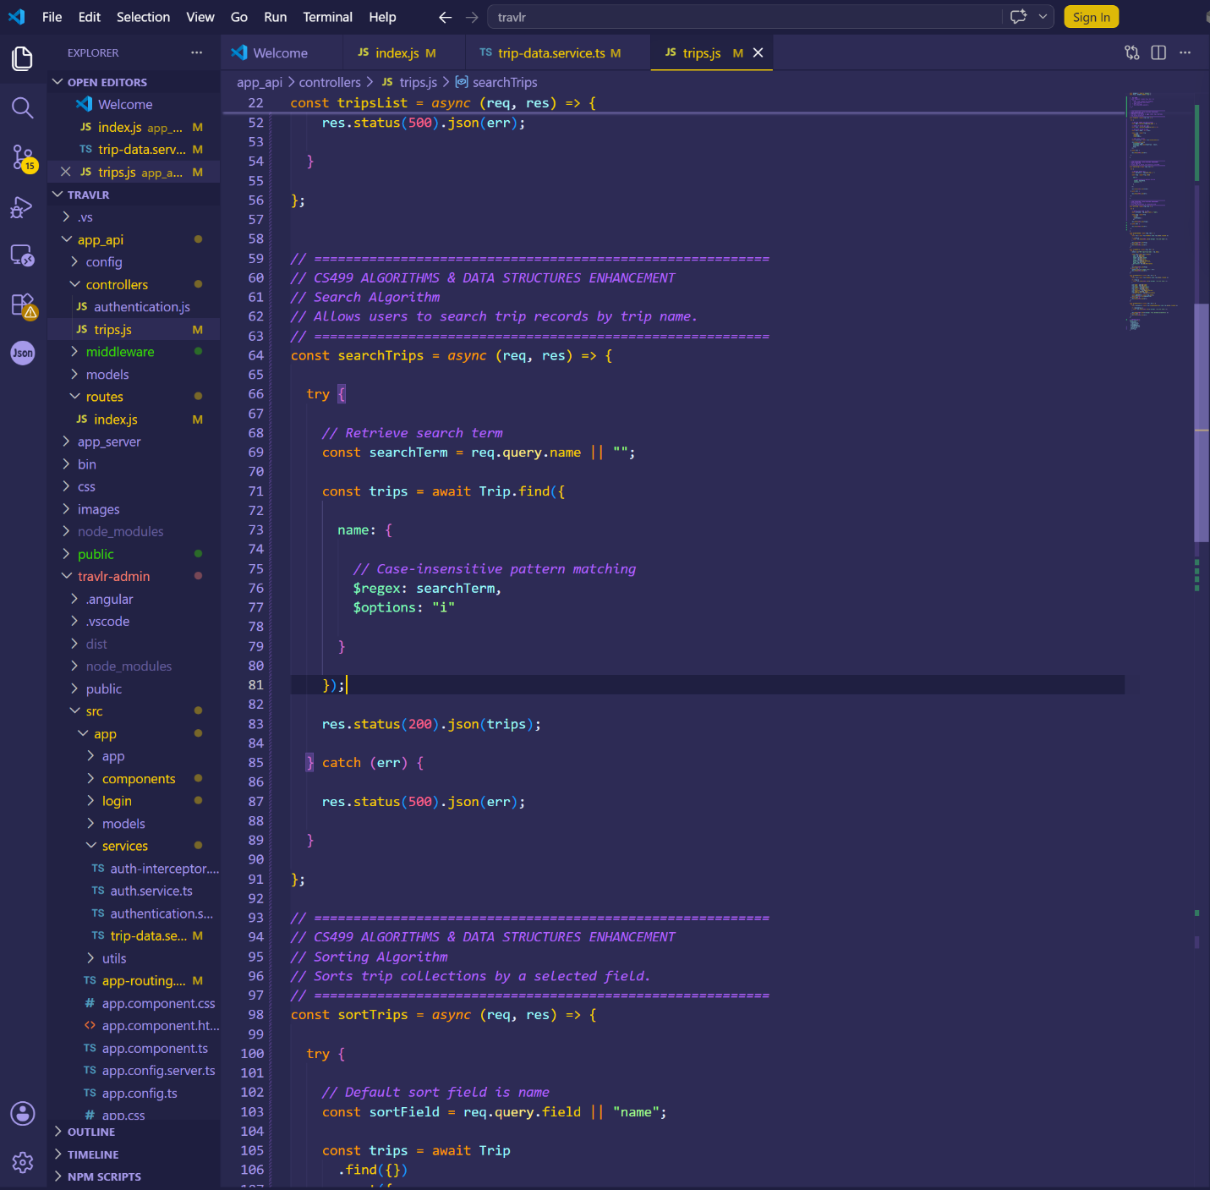
Figure 6. MongoDB Search Algorithm Implementation
This screenshot displays the searchTrips controller function. The implementation uses MongoDB regular expression matching with case-insensitive searching to locate records based on user-provided search criteria. This enhancement demonstrates practical application of search algorithms within a database environment.
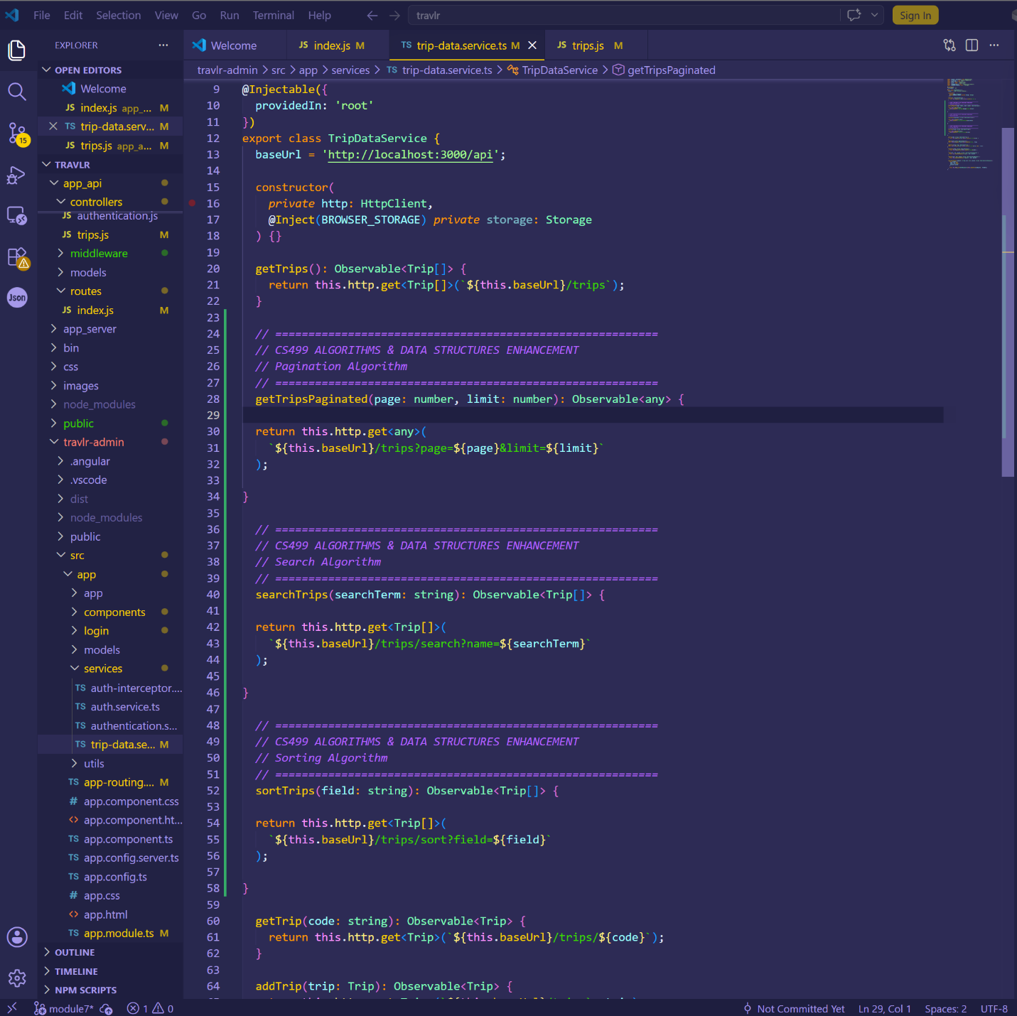
Figure 7. Angular Service Enhancements Supporting Data Retrieval
This screenshot displays the Angular service methods developed to support pagination, searching, and sorting operations. These reusable service functions communicate with the backend API and provide a structured approach for retrieving data collections throughout the application.
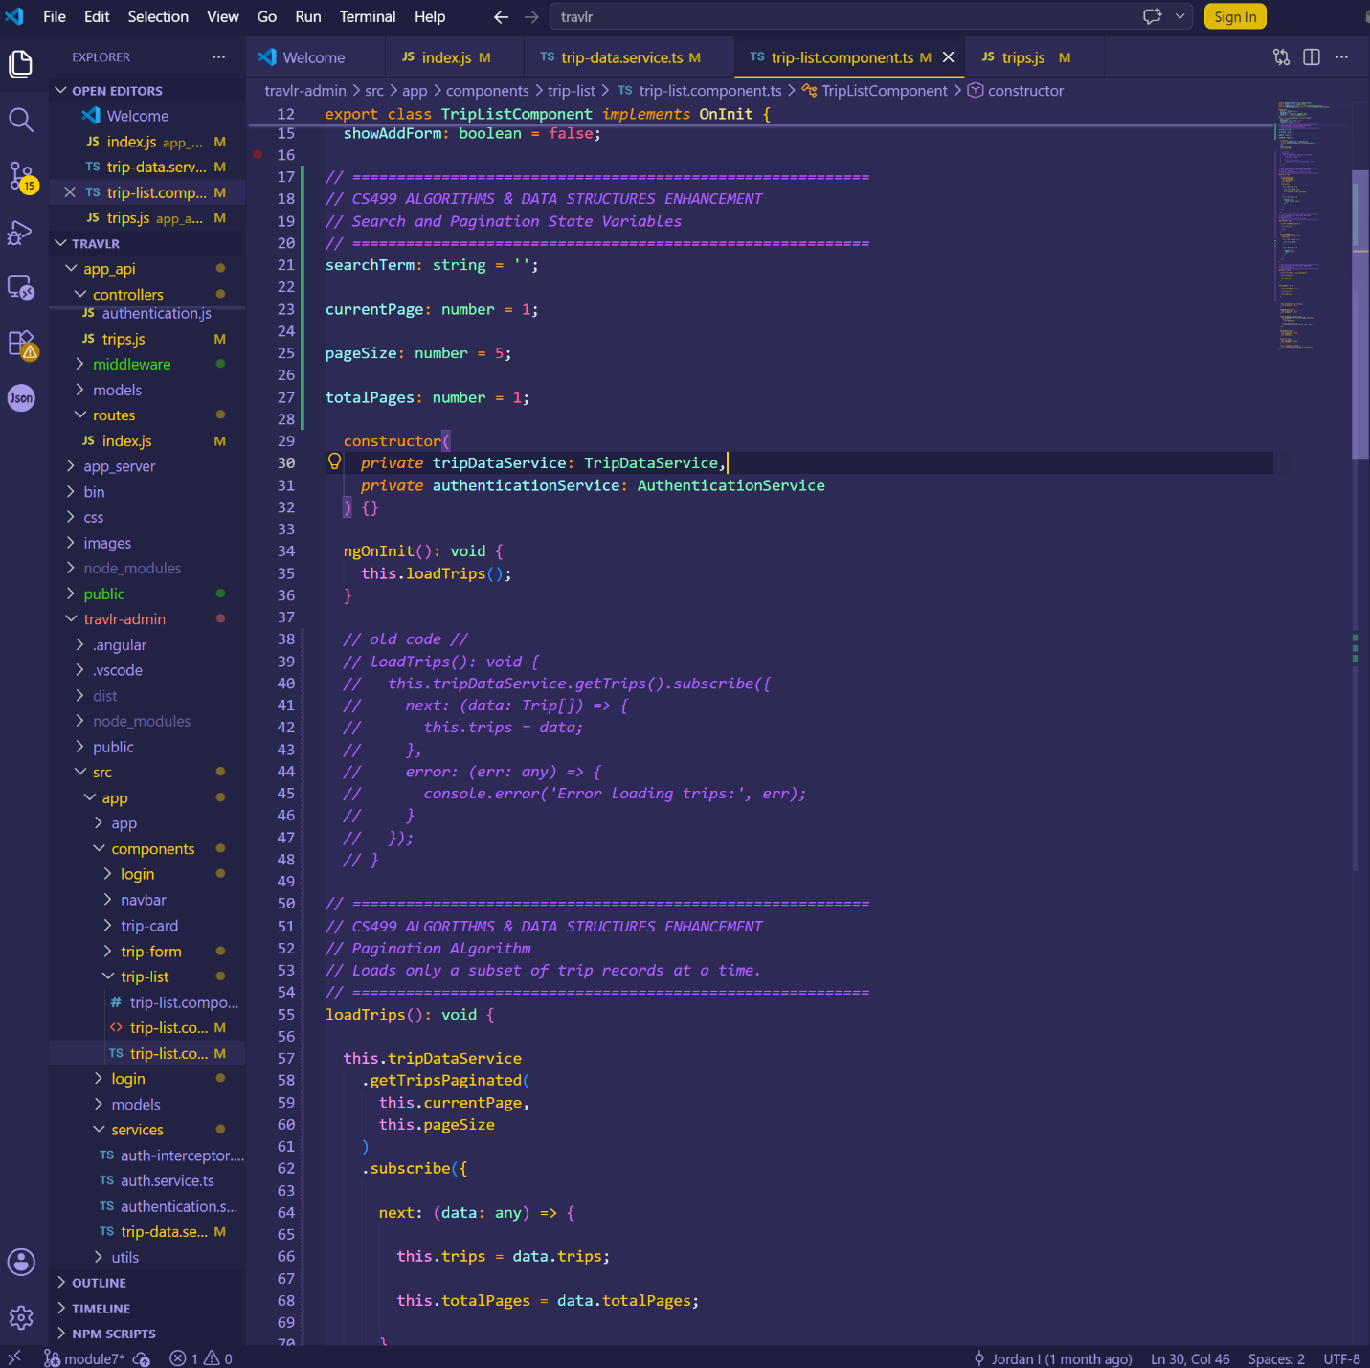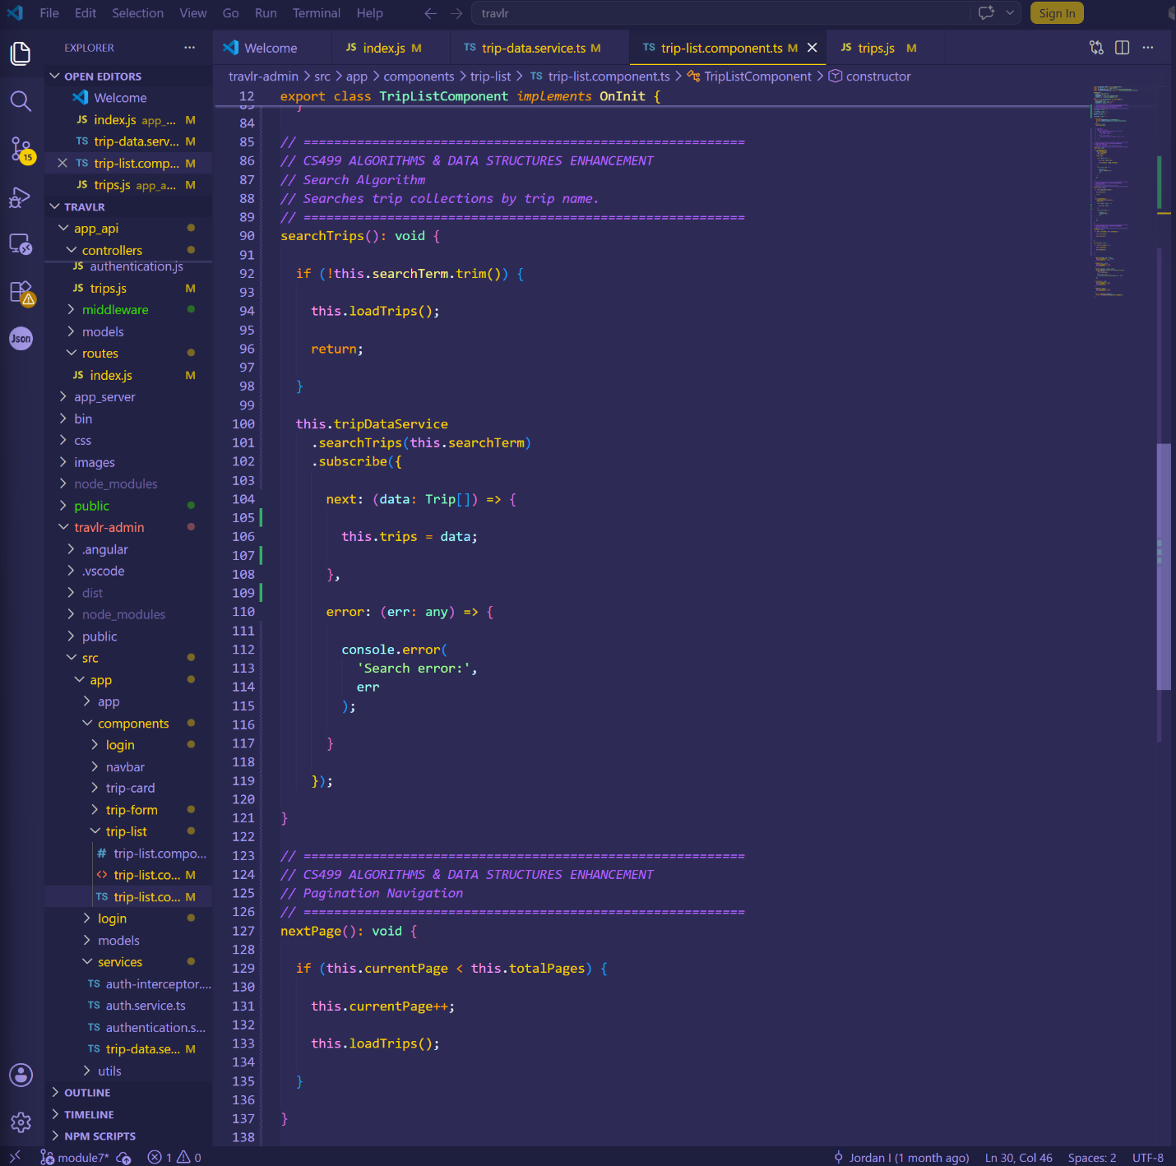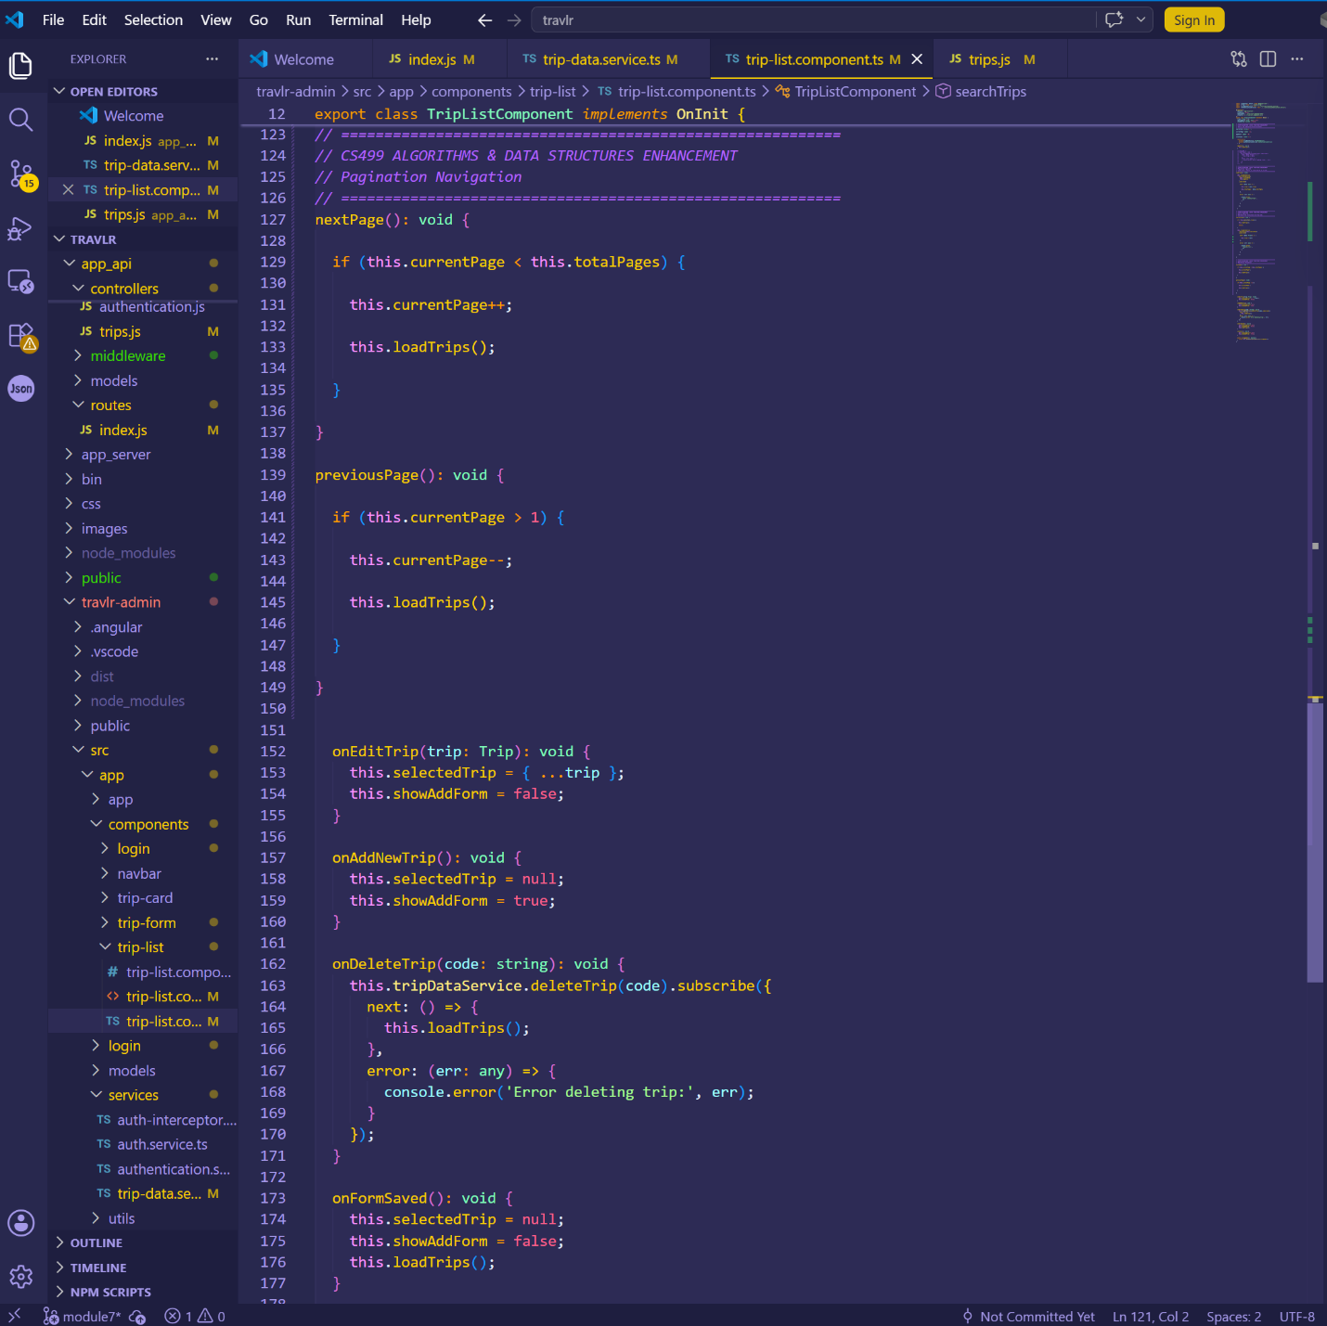
Figure 8. Frontend Search and Pagination Logic
This screenshot displays the frontend implementation responsible for processing pagination and search requests. The component manages user interactions, retrieves filtered data through Angular services, and dynamically updates the displayed trip collection. This enhancement improves both usability and application performance.

